Backyard Poultry

- Project Village :- Dumerdiha
- Farmer’s Name:- Basudev Das Mob. No.- 6202016205
- Address :- At- Dumerdiha, P.O -Baniyakura, PS- Katoria, Dist.-Banka, Pin – 813106.
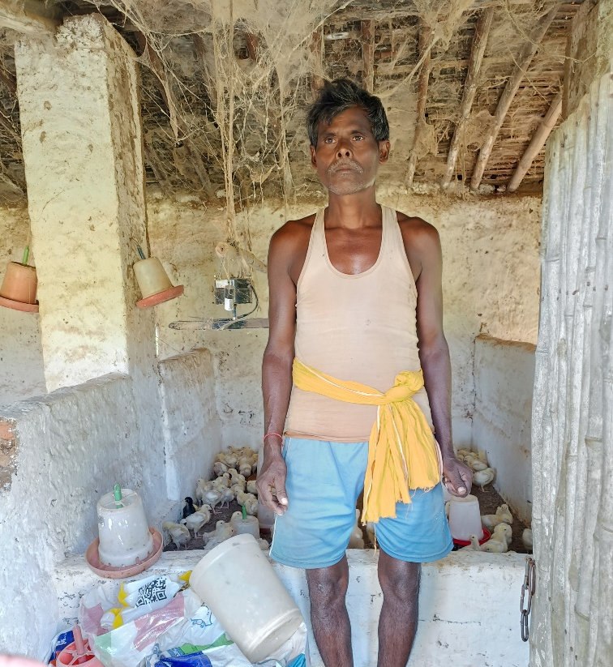
- Name of Activity:- Backyard Poultry
- Month of Initiation:- January 2022
- Problem Statement :-
To overcome low income deficiencies.

- Initiation Taken :-
Started household poultry with 14 hesa.

- Progress And Result :-
Hens have risen to 20 and earns daily.

- Impact:-
Others are doing now to add to their income.

- Inspiration :- Starting something always go better.
